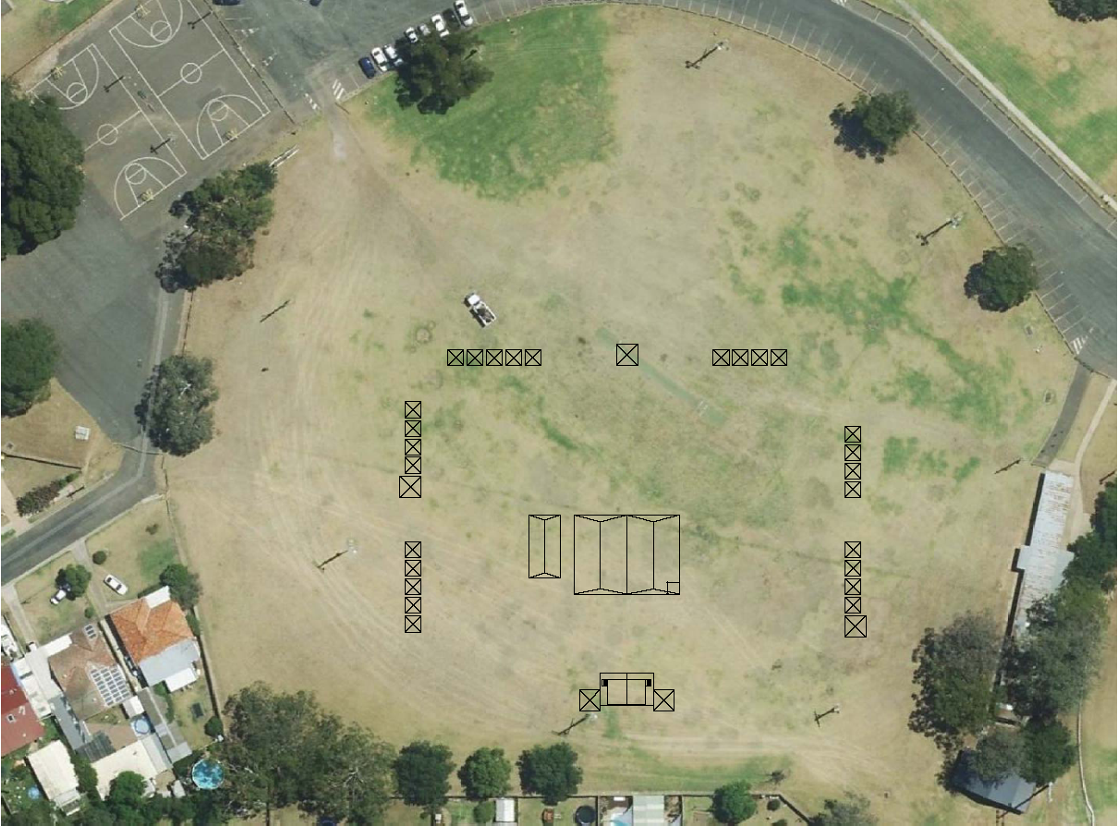

**STALL LIST**

**A1: Backstage Right**

**A2 Stage & Stage Cover**

**A3: Backstage Left**

**B1:**

**B2:**

**B3:**

**B4:**

**B5:**

**C1:**

**C2:**

**C3:**

**C4:** Sorry Bus. Hurse Van

**D1: Save the Children Van**

**D2: Gadigal Radio Van**

**E1:**

**E2:**

**E3:**

**E4:**

**E5:**

**F1: St. Johns 1st Aid**

**F2:**

**F3:**

**F4:**

**F5:**

**G1:**

**G2:**

**G3:**

**G4:**

**G5:**

**H1:**

**H2:**

**H3:**

**H4:**

**H5:**

**I1: Rotary Food Truck +Tent**

**I 2: MGRS Info tent**

**J1: Theatre style seating**

**J2: Elders Marquee**

**J3: Kids’ Activity Marquee**

**K1:**

**K2:**

**K3:**

**K4:**

**K5:**

**L1: Mental Illness Fellowship**

**L2: Aboriginal Health Services  
L3: Breast Screen NSW**

**L4: Benevolent Society**

**L5: Tharawal Aboriginal Corporation.**

Key

3metre x 3 metre stall

3m x 6m stall

4m x 4m stall

St. Johns First Aid Tent

First Aid Kit Location

Generator

Cool Room

Fire Hydrant and

Fire Blanket Location

Red Umbrella Tables

(1.5m diameter approx.)

Unisex Toilets

Universal Toilet

Display Police Van 2x8m

Ambulance

Truck – Display 2x8m

Fire Truck Display 3x10m

Rotary Food Tent and trailer 3x 8m

Save Children Van 2x8m

Gadigal Radio Van 3x8m

Sorry Business Hurse 2x8m

Stage Barriers

TOTAL STALLS (final numbers TBC 6/1/16)

3x3 = 21

3x 6 = 2

4 x4 = 18

PLAN IS NOT TO SCALE

Drafted by : Fiona Ng

Contact: fionag1ng@gmail.com

Mobile: 0430 187 952

**SITE PLAN - Version 4**

**Getting It Together Event – 21st January, Thursday 2016**

**Updated 24th December 2015**



G1

G2

G3

G4

G5 5

J3 J2 J1



L1 L2 L3 L4 L5

K1 K2 K3 K4 K5

F1 F2 F3 F4 F5

**I1**

**I2**

H1

H2

H3

H4

H5 5

D2

D1

C4

C3

C2

C1

B5

B4

B3

B2

B1 5



A2

A3 A1

E1 E2 E3 E4 E5



**Firies**

**Ambo’s**

**Ambo’s**

**Firies**

Police

Police